**Thomas Todd Forsyth (1839 – 1921)**

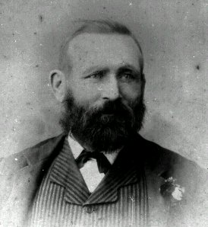

Alderman Willoughby Council (1881-1904, mayor 1882, 87, 93)

Co-founder St Leonards Bowling Club (1888-1900)

Co-founder Chatswood Bowling Club (1900-1915)

Advocate for Chinese market gardeners

Master Tanner

Thomas Todd Forsyth was born in Leeds in 1839. He grew up in Bermondsey London and became a tanner like his father and grandfather. In 1863 he migrated with his family to Sydney where he worked as a tanner. He, his brother Robert and father James built a tannery at Willoughby and operated a leather shop on Broadway. Tom was in charge of the tannery and Robert sales and marketing. When the business was sold in the early 1900s, Tom retired.

He served on Willoughby Council for over 27 years and was Mayor three times.

Tom was an avid lawn bowler and represented NSW on a number of occasions as well as being a pennant bowler for both St Leonards and Chatswood Clubs. He was a founding member of both Clubs, and the first life member at Chatswood.

Having had a poor upbringing in Bermondsey, Tom knew what it was to struggle. He regularly helped the poor Chinese market gardeners in the Willoughby area near his tannery, standing between them and the local authorities, advising them on financial matters and offering friendship, and in some cases, land. Several of them attended his funeral.