**‘RT’ (Robert Todd) Forsyth (1877-1939)**

Philanthropist

Board member Royal North Shore Hospital

Alderman Willoughby Council (1904-39, Mayor 1911, 15-18, 20-21, 27)

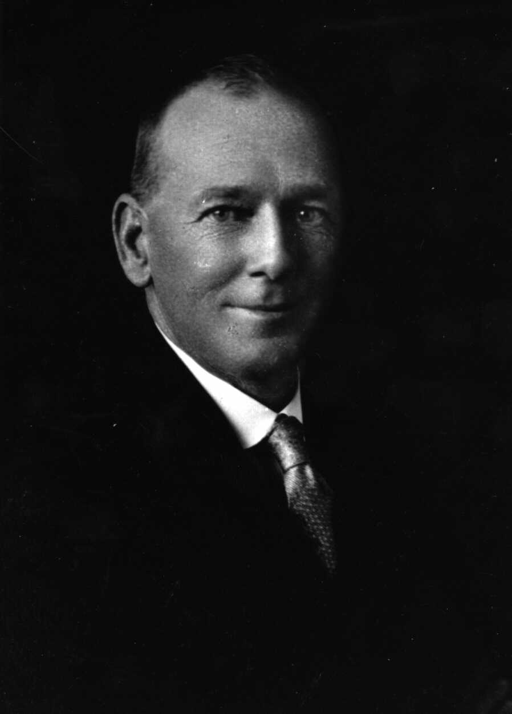

|  |  |
| --- | --- |
| Known as ‘RT’, Robert played a prominent role in Willoughby Council affairs, following in the footsteps of his father Thomas Todd Forsyth and grandfather James.  After attending Willoughby Pubic School and Sydney Grammar School, he established his own business, RT Forsyth House, Land & Estate Agent, in 1898. He operated from a small weatherboard office at the corner of Penshurst and Clanwilliam Streets in 1899. RT married Annie Bennett in 1904 and they moved into a new Federation house named *Kamaina* at 238 Penshurst Street.  RT Forsyth served on Willoughby Council from 1903 to 1939 and was elected mayor in 1911, 1915-18, 1920-21 and 1927. RT was a progressive alderman, touring the world to study local government in other countries. RT instigated the building of concrete roads and footpaths, many of which remain today. He also introduced ‘clean up week’.  His real estate business flourished during the boom years of the 1920s. He structured the business as a public company in 1929 and it continues to operate from the site of its second office at 236 Penshurst Street which opened in 1912.  RT was also a noted bowler and a member of the North Sydney Rotary Club.  RT’s wife Annie Bennett was awarded an MBE for her extensive charity work. |  |

Robert was the seventh child of Thomas Todd Forsyth (1839) and Ann Lile Lewis Forsyth.