**Robert Forsyth (1848 – 1917)**

**Stephana Forsyth, nee Gates, (1849-1914)**

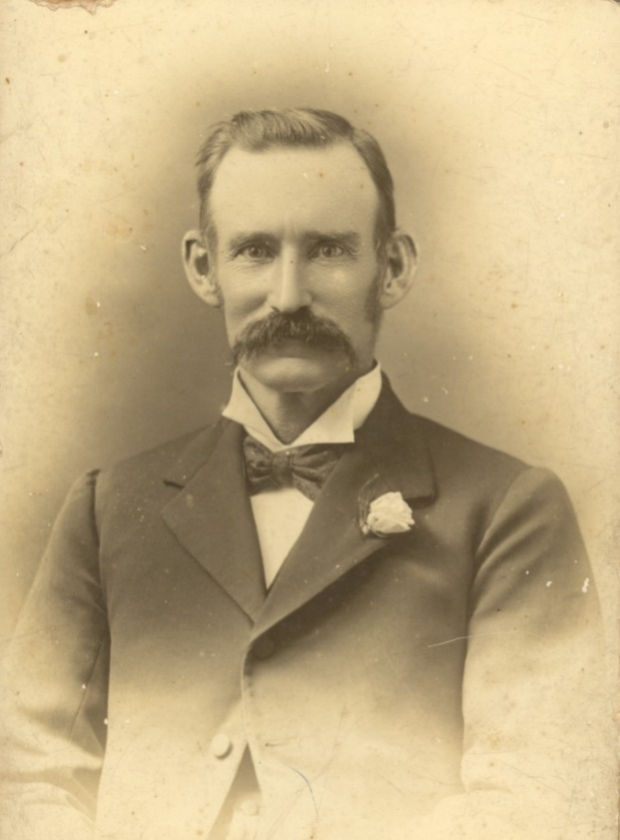

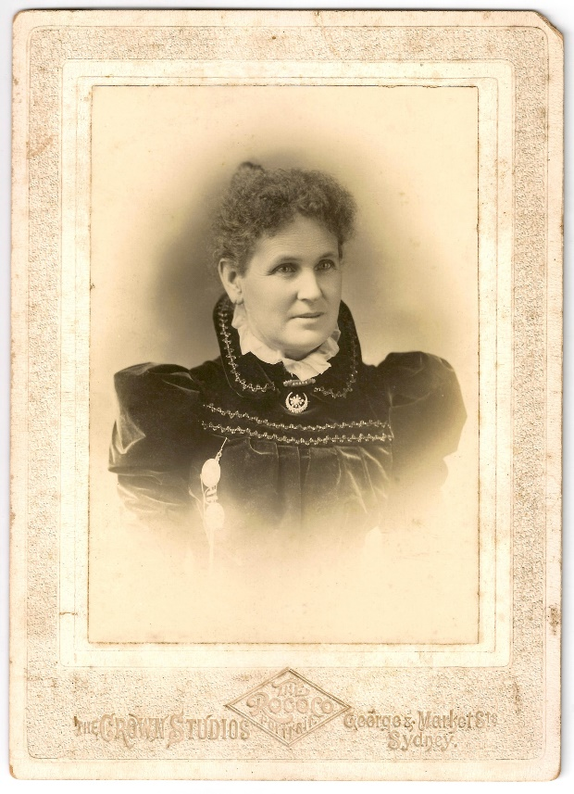

Foundation member St Leonards Bowling Club

Foundation Board member Crows Nest cottage hospital, and Board of Royal North Shore Hospital

Methodist church Mowbray Rd and Clanwilliam St

Leather merchant and tanner

Prize Chrysanthemum grower

Robert was born in Bermondsey London and trained as a tanner, before migrating to Sydney with his family in 1863. He worked with his brother Thomas and father James in the family leather business, mostly on the sales and marketing side at the family shop on Broadway. When the business closed in the early 1900s, Robert moved to North Sydney and worked as a leather merchant.

Robert and his wife Stephana were involved in supporting Royal North Shore Hospital where Robert was a foundation Board member. They also supported the Methodist church, including establishment of the Clanwilliam St Church. Robert was Trustee for a number of church properties and was choirmaster at the Mowbray Rd/Pacific Hwy church.