**Robert Charles Forsyth (1873 – 1947)**

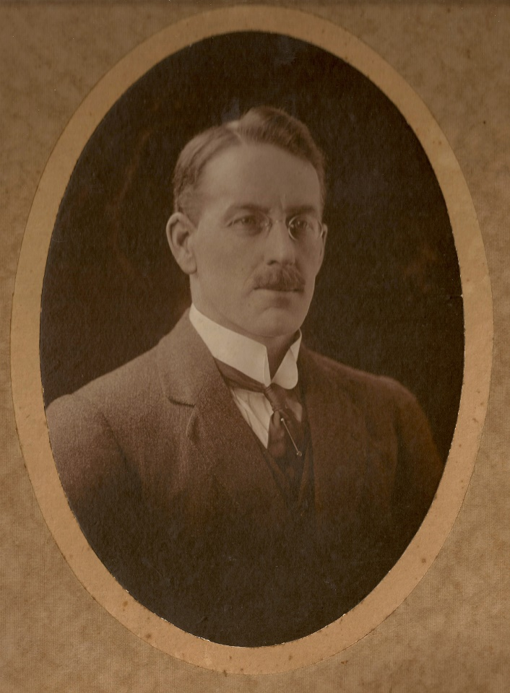

North Sydney Councillor (1923-47, Mayor 1934-35)

Sydney Water Board

Justice of the Peace

Robert was the second born son of Robert Forsyth (1848), who had worked with his father James and brother Thomas Todd to operate the Willoughby tannery and leather business in Broadway. When that business was dissolved, Robert snr ran a business as leather merchant. Around 1900, Robert moved to Hayberry St North Sydney, and it appears that he assisted his father in that business. Around 1905, father Robert also moved to North Sydney, and at some point renamed the business to R C Forsyth & Co Ltd, which was advertised as being in the ‘business of leather, tallow, skin, grindery and machinery merchants, leather manufacturers, tanners, dyers, wool scourers etc.’

Robert continued to live at North Sydney. He went into local government serving on North Sydney Council for over 20 years. When he was made mayor in 1934, his daughter, Cecily, was nominated as the Mayoress, the youngest Mayoress in the metropolitan area. (Robert’s first wife Bertha had died in 1932. He was married again to Ida Richards in 1938). During his time as mayor, work began on construction of the North Sydney swimming pool on the site of the first Milson's Point railway station and alongside the northern pylon of the Harbour bridge. Forsyth Park in Neutral Bay is named after him.

Robert also served on the Water Board representing the northern suburbs.