**John Rosewall Forsyth (1842 – 1928)**

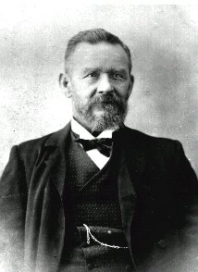

‘ Mr John Forsyth, 86, of Great North Road, Ryde died at his residence early today. He was an alderman of the district for fifteen years, and on two occasions was Mayor. He was a Past Master of the Ryde Masonic Lodge, and up till the time of his death was President of the Ryde School of Arts. He was also a member of the Ryde Bowling club.’

‘ The whole district mourns one who not only spent a life time in promoting happiness for others, but was as popular and hard working a citizen as ever lived in Ryde. His whole life was at once an example and an inspiration. He was admired by all who knew him, a man of wide reading and experience, a pleasant raconteur and an apt quotationist. He was always ready to help others and there were many in the district who will readily affirm that they owe their present blessing to his kindly aid.’

Alderman Ryde Council (1873~1893, mayor 1892~95)

Ryde School of Arts

Ryde Masonic Lodge (Master 1893-5)

Trustee of Dill McKay Homes

Secretary for Methodist Section of Field of Mars Cemetery

Ryde Bowling Club

Justice of the Peace

Tanner

John Rosewall Forsyth was born in Bermondsey London. Like his brothers, he went into the tanning trade, but John was more studios than his siblings, and throughout his life continued his love for reading and often quoted large passages of poems and text. After the family arrived in Sydney in 1863, John worked for a while with one of the larger tanning businesses, but when his father and brothers started a tannery in Willoughby, John decided to pursue his own path starting a tannery at Ryde. When he encountered water supply problems, he converted his facility to a bone mill, becoming one of the earliest fertiliser producers in the colony. Later he built several houses and operated a quarry. He was an alderman of Ryde Council and an active member of Ryde Bowling Club.