Annie Bennett Forsyth MBE ( 1880-1940)

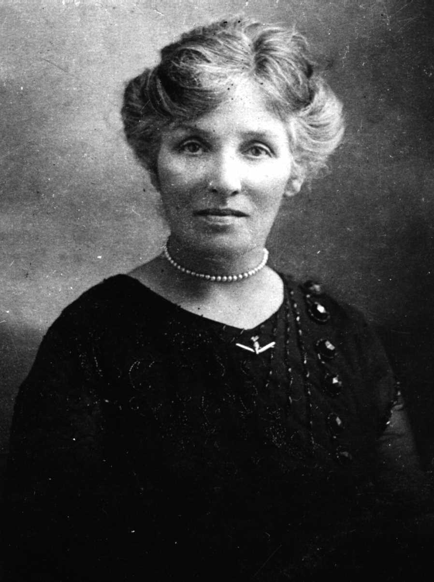

Social worker
Benevolent Society
Red Cross
Service League
Mater Hospital
Royal North Shore Hospital
Tresillian
Lady Mayoress

Mrs. Annie Forsyth, M.B.E., was a prominent social worker in the Willoughby district for over 20 years, and was Mayoress of Willoughby during the War years of 1915 1918. Among the many activities which engage her attention are the Willoughby Benevolent Society, the Willoughby Red Cross Society, of which she is President, the Service League, which she founded during the depression for the benefit of the poor, the Mater Misericordiae Hospital Auxiliary Service League, which she founded, and of which she is President, and the Royal North Shore Hospital Auxiliary Service League. She was the first president of the Tresillian North Mother craft training school.

Annie was married to RT Forsyth (1877), founder of RT Forsyth Real Estate.

